**KRUPACHARYA**

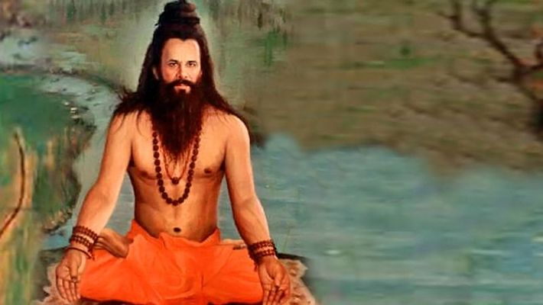

Kripa  also known as Kripacharya or Krupacharya or better phonetically written as Kṛpāchārya is fourth [Avatar](https://en.wikipedia.org/wiki/Avatar" \o "Avatar) of [Brahma](https://en.wikipedia.org/wiki/Brahma" \o "Saptarishi) and is an important character in the [Mahābhārata](https://en.wikipedia.org/wiki/Mah%C4%81bh%C4%81rata" \o "Mahābhārata), one of the [Chiranjivi](https://en.wikipedia.org/wiki/Chiranjivi" \o "Chiranjivi). He is the son of Śaradvān and Jānapadī, born in a particularly extraordinary manner. He is the grandson of [Maharishi Gautama](https://en.wikipedia.org/wiki/Maharishi_Gautam" \o "Maharishi Gautam). He is a descendant of sage [Angiras](https://en.wikipedia.org/wiki/Angiras_(sage)" \o "Angiras (sage)). He along with his sister Kripi were adopted by King [Shantanu](https://en.wikipedia.org/wiki/Shantanu" \o "Shantanu). Later on Kripa became an *[acharya](https://en.wikipedia.org/wiki/Acharya" \o "Acharya)*, teacher of the royal children, giving him the name *Kripacharya*. His twin sister Kripi married [Drona](https://en.wikipedia.org/wiki/Drona" \o "Drona). Kripa was among the Maharathis who fought on the Kauravas's side against the Pandavas in the [Kurukshetra war](https://en.wikipedia.org/wiki/Kurukshetra_war" \o "Kurukshetra war) in the [Hindu](https://en.wikipedia.org/wiki/Hindu" \o "Hindu) epic of the [Mahabharata](https://en.wikipedia.org/wiki/Mahabharata" \o "Mahabharata). Along with others, Kripa is considered to be foremost among the rishis in *[Kali Yuga](https://en.wikipedia.org/wiki/Kali_Yuga" \o "Kali Yuga)*. Kripa will also become one of the [Saptarishi](https://en.wikipedia.org/wiki/Saptarishi) in the 8th [Manvantara](https://en.wikipedia.org/wiki/Manvantara" \o "Manvantara).

**Early Life**

[Gautama Maharishi](https://en.wikipedia.org/wiki/Gautama_Maharishi) had a grandson called Śaradvān. Śaradvān was born with arrows, making clear he was a born [archer](https://en.wikipedia.org/wiki/Archery" \o "Archery). As he matured, he became such a great archer and began doing penance to become an unbeatable one. This threatened the gods, especially [Indra](https://en.wikipedia.org/wiki/Indra" \o "Indra). He then sent a beautiful [Apsara](https://en.wikipedia.org/wiki/Apsara" \o "Apsara), Janapadi, from heaven to distract the celibate saint. Śaradvān was distracted by the sight of such a beautiful woman and lost some control, dropping his weapons and retreating into the forest to undergo more penance. His semen fell on some weeds by the wayside, dividing the weeds into two - from which a boy and a girl were born. The king of [Hastinapura](https://en.wikipedia.org/wiki/Hastinapura), [Shantanu](https://en.wikipedia.org/wiki/Shantanu" \o "Shantanu) was out for hunting. A soldier of Shantanu saw the twins and brought them to the king. Shantanu became so compassionate towards them that he adopted them and named them Kripa and Kripi, "Kripa" meaning pity. As he adopted them out of pity. He decided to take them back with him to his palace.

When Śaradvān came to know of these children he came to the palace, revealed their identity and performed the various rituals which are performed for the children of [Brahmins](https://en.wikipedia.org/wiki/Brahmin" \o "Brahmin). He also taught the children archery, the [Vedas](https://en.wikipedia.org/wiki/Veda" \o "Veda), and other [Shastras](https://en.wikipedia.org/wiki/Shastra" \o "Shastra).

The children grew up to become experts in the art of warfare. Kripa was now assigned the task of teaching the young princes all about warfare. On reaching adulthood, Kripa was the chief priest at the court of [Hastinapura](https://en.wikipedia.org/wiki/Hastinapura" \o "Hastinapura). His twin sister [Kripi](https://en.wikipedia.org/wiki/Kripi" \o "Kripi) married [Drona](https://en.wikipedia.org/wiki/Drona" \o "Drona), the weapons master to the court - who, like her and her brother, had not been gestated in a womb, but outside the human body.

He fought in the great battle of [Kurukshetra](https://en.wikipedia.org/wiki/Kurukshetra" \o "Kurukshetra) for the [Kaurava](https://en.wikipedia.org/wiki/Kaurava" \o "Kaurava) side. He was one of the three survivors remaining from the Kaurava side. Afterwards, he was appointed to be the teacher and preceptor of [Parikshit](https://en.wikipedia.org/wiki/Parikshit" \o "Parikshit), the grandson of [Arjuna](https://en.wikipedia.org/wiki/Arjuna" \o "Arjuna).

**Role in Mahabharata**

In [Udyoga Parva](https://en.wikipedia.org/wiki/Udyoga_Parva" \o "Udyoga Parva) of the [Mahabharata](https://en.wikipedia.org/wiki/Mahabharata" \o "Mahabharata), [Bhishma](https://en.wikipedia.org/wiki/Bhishma" \o "Bhishma) declared Kripa as a mighty Maharathi, or a warrior capable of fighting 60,000 warriors simultaneously; circumspect in his mastery of all forms of weapons and combat skills.[[5]](https://en.wikipedia.org/wiki/Kripa" \l "cite_note-5)

As noted in sloka given below, he is one of the seven [Chiranjivin](https://en.wikipedia.org/wiki/Chiranjivin" \o "Chiranjivin) (the "immortals" who are to remain alive throughout the *[Kali Yuga](https://en.wikipedia.org/wiki/Kali_Yuga" \o "Kali Yuga)*.

अश्वत्थामा बलिर्व्यासो हनुमांश्च विभीषणः। कृपः परशुरामश्च सप्तैते चिरंजीविनः ।।

**On the 12th day of war**

**The noble Kripa, son of**[Sharadwata](https://www.vyasaonline.com/encyclopedia/sharadwata/" \o "Sharadwata Kripa's father.  " \t "_blank)**, with many small arrows resisted**[Vardhakshemi](https://www.vyasaonline.com/encyclopedia/vardhakshemi/" \o "Vardhakshemi Vardhakshemi belonged to the Vrishni race, fought along side Yudhishthira. On the 12th day of war The noble Kripa, son of Sharadwata, with many small arrows resisted Vardhakshemi of the Vrishni race who was the embodiment of wrath (in battle). They that looked at Kripa, son of Sharadwata, with…" \t "_blank)**of the**[Vrishni](https://www.vyasaonline.com/encyclopedia/vrishni/" \t "_blank" \o "Vrishni A royal lineage, a warrior race. Vardhakshemi was one of the Vrishni race.  )**race who was the embodiment of wrath (in battle). They that looked at Kripa, son of Sharadwata, with many small arrows, resisted Vardhakshemi of the Vrishni race who was the embodiment of wrath (in battle). They that looked at Kripa and Vardhakshemi, those heroes conversant with every mode of warfare, thus engaged in encountering each other, became so absorbed in it that, they could not attend to anything else.** Kripa spent his later days doing penance in the forest.

As per Hindu belief, Kripacharya is still alive.  
Some believe he roams the earth and suffers for the sins he committed on the night of the 18th day of Kurukshetra war.